Project Summary

Overview
Wildfires pose an immediate threat to air quality and have a significant impact on global atmospheric composition. Organic aerosol (OA) is a major component of wildfire plumes, which plays a critical role in determining plume optical properties and health effects. However, our understanding of OA evolution remains incomplete. In the near-field, field observations have reported substantial variability in OA trends with smoke age, yet a quantitative understanding of this variability is still lacking. During long-range transport, OA evolution is even less well characterized due to limited measurements, leaving the underlying processes and controlling variables poorly understood. In this study, we will analyze data from five field campaigns (SEAC⁴RS 2013, WE-CAN 2018, FIREX-AQ 2019, MBO 2019, and AEROMMA 2023), which collectively capture wildfire plume evolution across a wide range of spatial and temporal scales. In parallel, we will simulate plume evolution using a multi-scale modeling framework that includes WRF-Chem for continental-scale domains and large-eddy simulations (LES) for local, high-resolution domains. Together, these efforts will provide a comprehensive characterization of OA and related species from fire source to thousands of kilometers downwind.
Intellectual Merit
Understanding OA evolution in wildfire plumes is challenging due to the interplay of complex physical and chemical processes, variability in emissions, and limited measurements of aged smoke. To address these gaps, we propose an integrated approach that combines in-depth analysis of existing field observations and multi-scale atmospheric modeling. For the near-field, we will deploy a novel single transect analysis that minimizes the influence of temporal emission variability and enables more robust statistical interpretation compared to the traditional pseudo-Lagrangian analysis. We will interpret OA evolution in a conceptual framework defined by two synthetic variables that represent the two key processes governing OA formation: dilution-driven loss and chemistry-driven production. This approach will help explain the large variability in OA trends observed across field campaigns. To characterize OA evolution during long-range transport, we will synthesize data from multiple campaigns. When comparing different wildfires, we will correct for differences in OA emission ratios by developing a new parameterization based on measurable metrics in aged plumes (e.g., ΔCH₃CN/ΔHCN). Observed OA trends will be used to evaluate the performance of regional model WRF-Chem, and model sensitivity tests will be conducted to probe the roles of different processes in driving the OA evolution, with a focus on SOA formation and heterogenous oxidation of OA. This comprehensive approach will enable a robust, diagnostic evaluation of wildfire OA chemistry from source to downwind regions.
Broader Impacts
The increasing frequency and intensity of extreme wildfire events have heightened public concern over their environmental and health impacts. Leveraging this awareness, the PIs will collaborate to develop engaging outreach activities and educational seminars targeted at K-12 educators. In partnership with Baylor University’s Mayborn Museum and the Washington University Institute for School Partnership, we will create visually engaging materials and hands-on experiments that explore wildfire science and its connections to climate change and air quality. These activities will empower educators, students, and families with knowledge about wildfire risks and preparation strategies. Additionally, students, teachers, and parents will be invited to tour the PIs’ laboratories, fostering curiosity and enthusiasm for science through direct exposure to active research. These efforts aim to spark long-term interest in STEM education and careers among young learners. Finally, this collaborative project will support two full-time Ph.D. students and two undergraduate summer interns, co-advised by PIs Xu and Li. A key goal is to cultivate a new generation of scientists with deep expertise in both experimental techniques and atmospheric modeling.

1. Background and Questions
Wildfires present imminent threats to life, property, air quality, and climate. Throughout the 2000s, fires in North America have grown larger, more frequent, and increasingly widespread¹. These alarming trends have significantly impacted air quality over the past two decades, partially counteracting the progress made in reducing anthropogenic emissions^{2, 3}. The spatial impact of wildfires is extensive, affecting not only cities in the wildfire-prone western U.S. but also reaching cities in the east, as smoke from wildfires in western and Canadian regions can traverse the continent under strong upper-level westerly jet stream flow⁴⁻⁹. Looking ahead to a future marked by warmer temperatures and extended dry seasons, the influence of wildfires on atmospheric composition is poised to intensify¹⁰.
Organic aerosol (OA) is an important component in wildfire plumes, because it dominates the submicron particle mass and plays a key role in determining plume optical properties, cloud-forming potential, and health effects¹¹⁻¹⁵. After emission, the OA concentration evolves during transport. This evolution is commonly characterized by the normalized excess mixing ratio (ΔOA/ΔCO), where the Δ symbol denotes the difference between concentrations in smoke and background air and ΔOA is normalized by ΔCO to correct for dilution. OA evolution is governed by several processes (i.e., dilution-drive evaporation, oxidation, photolysis) and variables (e.g., initial OA concentration, OA volatility, oxidant level) (Figure 1).
The interplay of several processes and variables presents a significant challenge to understanding OA evolution. For example, dilution decreases ΔOA/ΔCO by evaporating OA, yet the resulting vapors may oxidize to form secondary organic aerosol (SOA), increasing ΔOA/ΔCO. SOA formation is strongly influenced by oxidant levels, particularly hydroxyl radicals (OH), whose concentrations are controlled by photolysis rates and the abundance of precursors such as HONO, ozone (O₃), and formaldehyde. Photolysis rates depend on solar radiation and aerosol loading, while precursor concentrations are influenced by combustion conditions and plume age. Overall, this complex and dynamic interplay among processes makes OA evolution highly variable and difficult to predict with current understanding and models.
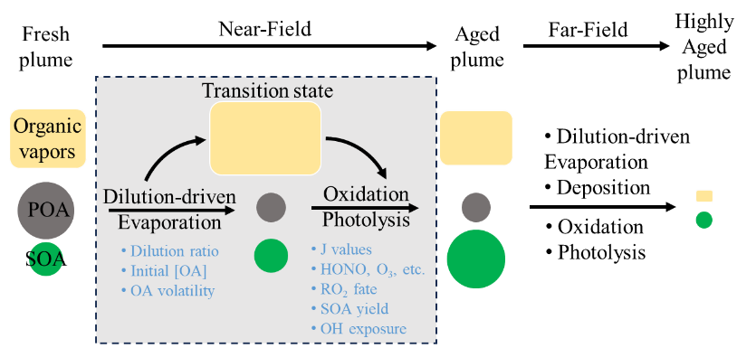
In the near-field (within ~100 km downwind), airborne field measurements have reported substantial variability in ΔOA/ΔCO with smoke age, including net loss, no change, and net gain. This variability is generally attributed to the competing influences of dilution-driven evaporation, which reduces ΔOA/ΔCO, and chemistry-driven SOA formation, which increases ΔOA/ΔCO. While this qualitative understanding is widely accepted, quantifying the relative contributions of these two processes remains a major challenge. For example, Palm et al. suggested that substantial SOA formation offsets OA evaporation, resulting in no net change of OA¹¹. In contrast, Pagonis et al. argued that SOA formation plays a minor role and that OA evolution is dominated by dilution-driven evaporation¹⁶.

Figure 1. Schematic of OA evolution in wildfire plumes. Organic vapors refer to gas-phase organic species spanning a wide range of volatility. POA: primary organic aerosol. SOA: secondary organic aerosol. The symbol size represents the relative abundance. Blue text indicates variables that influence the OA evolution.
Atmospheric models struggle to accurately reproduce observed OA evolution trends. Akherati et al.¹⁷ developed a comprehensive kinetic model that incorporated detailed OA processes, but it underestimated the observed ΔOA/ΔCO during the WE-CAN campaign. A subsequent study by He et al.¹⁸ improved the model by incorporating a full volatility distribution at the precursor level, resulting in better agreement with airborne measurements. However, a closer inspection of He et al. reveals that the model only correctly captured OA evolution trends for half of the studied wildfire plumes. This discrepancy may arise from several sources: inaccurate emission profiles or their mapping to surrogate species; uncertainties in OA volatility and SOA formation parameters; or missing chemical processes in the model.
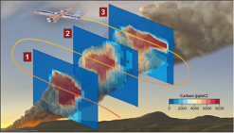
In addition to model-related uncertainties, discrepancies between models and measurements may arise from measurements themselves. Aircraft studies typically aim to track the same plume as it moves downwind, analyzing its evolution through comparing consecutive transects in a Lagrangian framework¹⁹⁻²⁵ (Figure X). However, in practice, the sampled transects may originate from different times and locations²⁶. Consequently, variations in emissions at the source could influence observed ΔOA/ΔCO trends, complicating the distinction between source variability and atmospheric processing. The use of pseudo-Lagrangian analysis under dynamic fire conditions can thus introduce bias in inferred OA evolution and model evaluation.
Figure X. Illustration of pseudo-Lagrangian sampling in the near-field (e.g., WE-CAN and FIREX-AQ). Adapted from Stockwell et al. 2022.
Synopsis: In the near-field, we have a qualitative understanding of OA evolution, but quantitative prediction is difficult. Discrepancies between models and measurements arise from limitations in both model and measurement. Variability in fire emissions complicates traditional pseudo-Lagrangian analysis.
Some wildfire plumes undergo long-range transport, but OA evolution during long-range transport remains poorly understood. This is partly because measurements of aged wildfire plumes are sparse. Most recent field campaigns, such as BBOP (2013), WE-CAN (2018), and FIREX-AQ (2019), focused on near-field plumes^{11, 21, 23, 27-29}, while measurements of aged wildfire plumes mainly come from stationary ground sites at remote oceanic or mountainous regions. These measurements are difficult to interpret due to challenges in plume identification, background subtraction, mixing with other sources, and they often lack key chemical species such as speciated VOCs. Targeted aircraft sampling of aged smoke is challenging. There is an urgent need for more measurements of aged smoke plume to better understand long-range evolution.
Existing observations suggest that ΔOA/ΔCO decreases during long-range transport. For example, Farley et al. combined near-source aircraft data with downwind measurements at Mt. Bachelor and showed that ΔOA/ΔCO decreases between 20 and 100 hours^{30, 31}. Sedlacek et al. also inferred a decreasing trend based on reduced coating thickness of black carbon (BC) over 12 days. In contrast, a modeling study by He et al.¹⁸ predicted that ΔOA/ΔCO increases fourfold after about 100 hours of aging. The cause of this difference between field observations and modeling is unclear, but may stem from missing processes in the model, such as OA photolysis and heterogeneous oxidation. Notably, the OA parameterizations in He et al. were derived from laboratory studies, validated only with near-field data, and extrapolated to the far-field without observational constraints. Therefore, rigorous model evaluation against long-range field observations is essential to advance our understanding of OA evolution during wildfire plume transport.
Besides measurement scarcity, another challenge in studying long-range OA evolution is the lack of information on initial emissions. To quantify OA changes, both the measured ΔOA/ΔCO in aged plume (denoted as (ΔOA/ΔCO)_{measured}) and the value initially emitted (denoted as (ΔOA/ΔCO)_{emitted}) must be known. Ideally, one would track the same plume from source to receptor, but such measurements are difficult. An alternative approach is to compare measurements from different fires sampled at varying downwind distances. However, a limitation in this approach is that (ΔOA/ΔCO)_{emitted} depends strongly on fuel type and burn conditions²⁹, and failing to account for this variability can lead to inaccurate representation about plume evolution. For example, our recent study on brown carbon evolution showed that ignoring emission variability underestimated the decay rate by 40%³². Thus, it is necessary to develop a method to estimate (ΔOA/ΔCO)_{emitted}, and thereby quantify the OA evolution.
Synopsis: In the far-field, our understanding of OA evolution is limited by sparse measurements. One approach to quantify OA evolution is to synthesize measurements from fires across temporal scales. Direct comparison between plumes requires accounting for fire-to-fire variability in initial emissions.
In summary, major gaps remain in our understanding of OA evolution in wildfire plumes. These gaps arise from the complex interplay of physical and chemical processes, variability in fire emissions that challenges traditional Lagrangian analysis, sparse measurements of aged smoke, and unknown initial emissions that hinders comparisons across wildfires.

2. Objectives, Research Questions, and Hypotheses
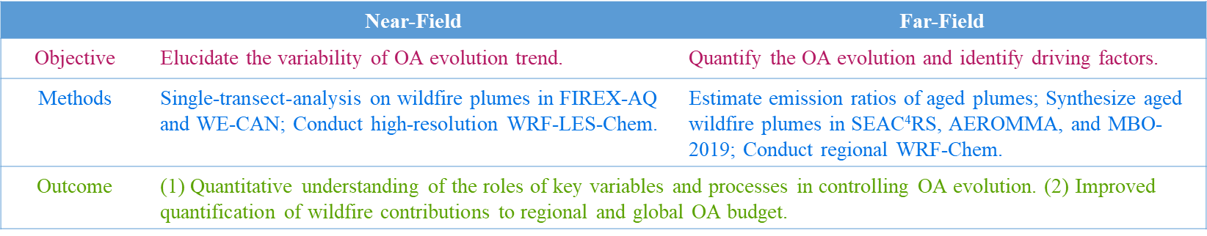
The overarching objective of this research is to comprehensively characterize the evolution of OA and related species in wildfire plumes from the fire source to thousands of kilometers downwind. The ultimate outcome will be a mechanistic understanding of the chemical and physical processes driving plume evolution and improved representation of these processes in atmospheric models. To achieve this, we focus on three key objectives and associated research questions (RQs):
Objective 1: Elucidate the near-field evolution of OA in wildfire plumes.
- Questions: Why is the trend of OA evolution in the near field highly variable? How can we disentangle the interplay of different variables that drive the OA evolution?
- Hypothesis: The near-field evolution of OA is governed by the competition between dilution-driven evaporation and chemistry-driven SOA formation. Both processes are influenced by multiple factors, making it challenging to quantify their relative contributions and predict OA evolution. We hypothesize that it is feasible to synthesize multiple variables into two composite parameters that represent the dominant physical and chemical processes. These synthetic parameters can then be used to explain the observed variability in OA evolution across different fires.
Objective 2: Investigate the evolution of OA during long-range transport.
- Questions: How does OA evolve during long-range transport? What processes influence its evolution during long-range transport?
- Hypothesis: ∆OA/∆CO decreases during long-range transport, consistent with previous field observations. However, the decay rate reported in earlier studies may be inaccurate due to unaccounted variability in initial OA emission ratios. The decrease in ∆OA/∆CO is primarily driven by limited SOA formation and heterogeneous oxidation of OA.

3. Project Team and Strengths
The project team is led by two investigators, Lu Xu and Yang Li, with expertise in atmospheric measurements and modeling, respectively. The PI Xu is an experimentalist and participated in the FIREX-AQ and AEROMMA campaigns. PI Xu has conducted extensive analyses of the wildfire chemistry, delving into O₃ chemistry³³, VOC emissions^{34, 35}, brown carbon evolution^{32, 36}, and reactive nitrogen compounds³⁷. The PI Li is an atmospheric modeler with expertise in multi-scale atmospheric chemistry transport modeling and assessing the wildfire impacts on air quality^{10, 38-40}. PI Li has further developed and applied the Large-Eddy Simulation (LES) framework in the Weather Research and Forecasting model coupled with Chemistry (WRF-Chem) to investigate atmospheric chemistry studies across rural and urban environments⁴¹.
Our technical approach synergistically integrates field measurements and atmospheric modeling. Field measurements will be used to evaluate model simulations, discern poorly represented chemistry and processes, and improve the overall accuracy and reliability of the modeling framework. Additionally, modeling with sensitivity tests will allow the identification of the roles of specific parameters, a challenge when relying solely on field measurements. Thus, the combined strengths of PIs form a robust foundation for the project's success.

4. Technical Approach and Methodology

4.1 Field Campaigns and Model Setup
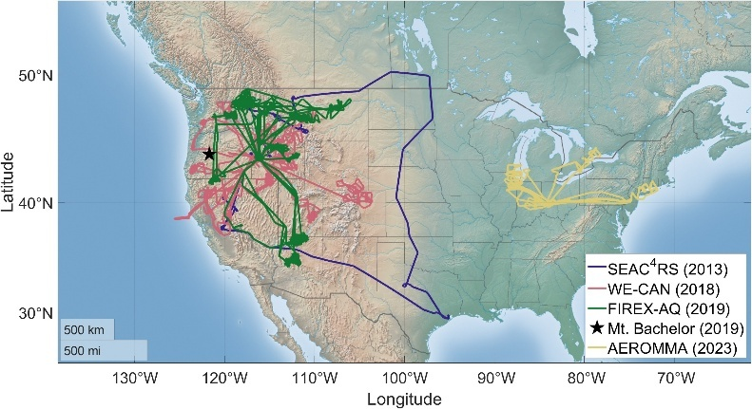
4.1.1 Field Campaigns. We will synthesize measurements from five recent wildfire campaigns, including SEAC⁴RS 2013, WE-CAN 2018, FIREX-AQ 2019, Mt. Bachelor 2019, and AEROMMA 2023 (Figure 2). These field campaigns are selected because they had extensive instrument payloads capable of measuring key chemical species required for our analysis (Table 4-1). In addition, these campaigns collectively capture wildfire emissions and their atmospheric evolution over a wide range of temporal scales, enabling a holistic investigation of wildfire plume evolution. Most wildfire plumes sampled in these campaigns were in the free troposphere, the focus of our analysis, as this minimizes the influence of urban emissions. A brief overview of each campaign is provided below.
Figure 2. Flight tracks of the four airborne campaigns and locations of two ground-based campaigns relevant to this study.
WE-CAN 2018 and FIREX-AQ 2019 were two airborne campaigns conducted aboard the NSF/NCAR C130 and NASA DC8, respectively. They focused on the near-field evolution (< ~100 km and <~10 hr) of wildfire emissions. Fuel types across the western U.S have been investigated^{21, 27, 42}. In both campaigns, the aircraft typically followed a ladder-pattern sampling (LPS) strategy, consisting of multiple crosswind transects through a smoke plume at different downwind distances from a wildfire (Figure X).
SEAC⁴RS 2013 was an airborne campaign conducted aboard NASA’s DC-8 aircraft. We will analyze two flights conducted on August 26 and 27, 2013, which tracked smoke from the Rim and Elk Complex Fires over two consecutive days of transport^{33,41}. While previous studies have examined the evolution of VOCs and brown carbon for these fires^{43, 44}, OA evolution remains unexplored.
MBO 2019 was a ground-based campaign conducted in August 2019 at the Mt. Bachelor Observatory (2764 m a.s.l.) in Oregon. The site is influenced by free troposphere air masses at night. Aged wildfire plumes from California were measured, with estimated transport times ranging from 10 to 200 hours ^{28, 30, 31}. This dataset provides a valuable link between the <10 hr plumes observed during WE-CAN and FIREX-AQ and the >1 day plumes sampled in AEROMMA.
AEROMMA 2023 was an airborne campaign conducted aboard NASA DC-8 aircraft. In 2023 July and August, the aircraft performed numerous spirals in the northeastern U.S., frequently intercepting wildfire plumes. For example, Figure 8 shows vertical profiles of HCN, CH₃CN, benzene, CO, and OA from a spiral near Detroit, Michigan. All tracers exhibit elevated concentrations between 1.5 and 2 km, indicating the presence of a wildfire plume. Using this approach, more than 60 wildfire plumes in the free troposphere have been identified. Back-trajectory analysis combined with satellite-based fire hotspot detections indicates that most plumes originated from the western U.S. or Canada, with estimated transport times ranging from 1 to 7 days. This dataset provides an unprecedented dataset of aged wildfire plumes.
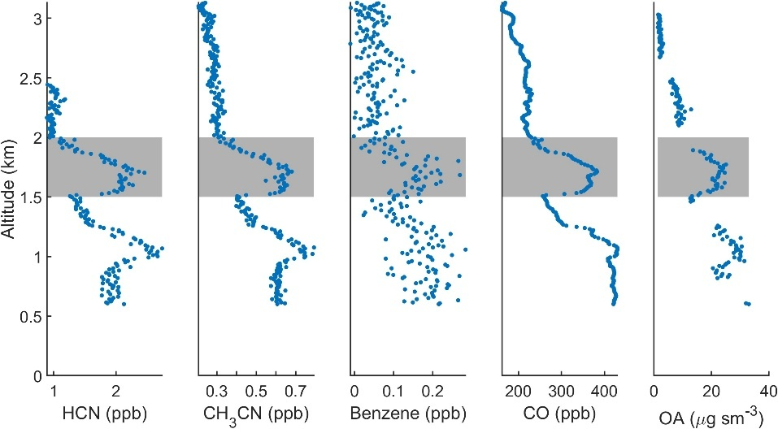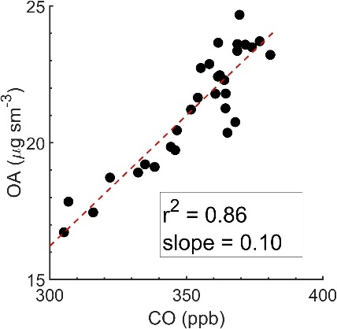

Figure 8. Vertical profiles of trace gases from one spiral over Detroit, MI, with the shaded area highlighting the wildfire plume. The right panel shows the correlation between OA and CO for this wildfire plume, and the slope from the fitting represents the ∆OA/∆CO.
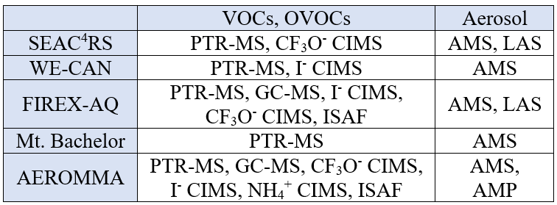
In this proposal, we use the term plume transect to refer to the sampling of wildfire plumes. For SEAC⁴RS, WE-CAN, and FIREX-AQ, a plume transect is defined as a segment of the aircraft flight path intersecting a wildfire plume roughly perpendicular to the wind direction, typically at a constant altitude. For AEROMMA, a plume transect refers to a wildfire-influenced layer intercepted during vertical spiral sampling. For MBO-2019 ground measurements, a plume transect is defined as a time period with elevated CO, aerosol mass concentration, and scattering coefficient as discussed in Farley et al.³⁰
(a) Acronyms: OVOCs (Oxygenated VOCs); PTR-MS (Proton Transfer Reaction - Mass Spectrometry); CIMS (Chemical Ionization Mass Spectrometry); ISAF (In Situ Airborne Formaldehyde); GC-MS (Gas Chromatography - Mass Spectrometry); FT-IR (Fourier Transform Infrared Spectroscopy); AMS (High Resolution - Aerosol Mass Spectrometer); LAS (laser aerosol spectrometer); AMP (Aerosol Microphysical Properties instrument suite, containing 5-chan CPC, Ultra-High Sensitivity Aerosol Size Spectrometer, and Coarse Mode Aerosol Size Spectrometer).
(b) Other species of interest but not listed in this table include CO, CO₂, NO_{x}, H₂O₂, HNO₃, actinic flux, and SO₂.
Table 4-1: Key species of interest in this study and their corresponding instruments.
Data from SEAC⁴RS, WE-CAN, FIREX-AQ, and AEROMMA are publicly available. They have already been downloaded and utilized in our previous studies on near-field ozone evolution³³ and brown carbon evolution³², enabling a rapid start to the proposed work. Data from the MBO-2019 campaign will be provided by its PIs, Drs. Qi Zhang and Lu Hu (see supporting letters).
4.1.2 Modeling Setup. We will employ multi-scale modeling to achieve process-level understanding of wildfire OA evolution. Regional WRF-Chem will be used to investigate OA evolution during long-range smoke transport. To resolve near-field processes, we will use the LES mode in WRF-Chem (WRF-LES-Chem) at ~100 m resolution, focusing on the immediate vicinity of selected wildfires.
The simulation periods will be selected to align with the field campaigns. Specifically, the WRF-Chem simulations will overlap with the 2019 FIREX-AQ and 2023 AEROMMA campaigns, representing years with relatively low and high fire activity, respectively. Due to the high computational cost of LES modeling, WRF-LES-Chem will be applied to one well-characterized wildfire with abundant supporting observations. We will focus on the Williams Flats fire, sampled extensively during FIREX-AQ. This large wildfire in Washington State burned over several days and was the most intensively sampled and studied fire of the campaign, providing an exceptional dataset for model evaluation^{33, 45, 46}.
For wildfire emissions, we will utilize the Fire Inventory from NCAR (FINNv2.5), which is publicly available on the NCAR website and currently spans the years 2002-2023, sufficient to support the proposed study of all the above-mentioned fire campaigns. For biogenic and anthropogenic emissions, we will use the Model of Emissions of Gases and Aerosols from Nature (MEGAN) and the most recent version of the National Emissions Inventory (NEI). The all-emission simulations aim to provide more accurate representations of the realistic atmosphere, enabling a more robust evaluation through field observations. For meteorological initial and boundary conditions, HRRR meteorological fields (3-km resolution) will be employed⁴⁷. The Yonsei University (YSU) PBL scheme will be utilized to parameterize boundary layer processes for the mesoscale domains (D01-D03)^{48, 49}. In the LES domain (D04), turbulent eddies will be explicitly resolved and PBL dynamics will be better simulated.
We will use the MOZART-MOSAIC chemical mechanism to simulate both trace gases and SOA, a more comprehensive scheme compared to the gas only one in a previous WRF-LES-Chem study⁴⁶ on the same fire. The Model for Ozone and Related Chemical Tracers version 4 (MOZART-4) includes 85 gas-phase species, 39 photolysis reactions, 157 gas-phase reactions, and 12 bulk aerosol compounds. It features updated oxidation schemes for isoprene and other VOCs, including lumped large alkanes (BIGALK), toluene, and biogenic VOCs. We will integrate simplified furan chemistry into MOZART-4 based on previous studies^{46, 50}. MOZART-4 also employs the Fast Tropospheric Ultraviolet-Visible (FTUV) photolysis scheme, which dynamically accounts for the effects of clouds and aerosols⁵¹.
For aerosol representation, we will use the Model for Simulating Aerosol Interactions and Chemistry (MOSAIC)⁵¹⁻⁵³. Within the MOSAIC framework, SOA formation is treated using the VBS approach based on the oxidation of VOCs by grouping them into bins based on their volatility and water solubility^{54, 55}, allowing us to separate and account for the dilution-driven evaporation of OA. We will adopt the 7-bin configuration with saturation concentrations ranging from 10⁻² to 10⁴ µg m⁻³. We will use VBS parameters derived from in situ measurements during FIREX-AQ.
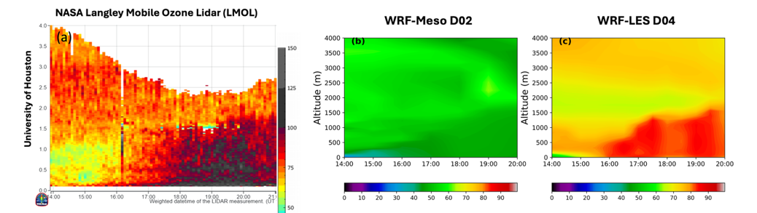

Figure 3: Vertical cross-sections of the temporal evolution of O₃ profiles (ppb) from 12:30 UTC on September 8, 2021, to 00:00 UTC on September 9, 2021 at the University of Houston LMOL site. (a) Gound-based lidar measurements. (b) Mesoscale model results (domain D02). (c) LES model results (domain D04).
While WRF-Chem is widely used to assess wildfire impacts on regional air quality, applications of WRF-LES-Chem remain limited. WRF-LES-Chem is a critical tool for resolving near-field plume structure and chemistry, as it explicitly resolve turbulent mixing and represent realistic chemistry-turbulence interactions. This advantage is demonstrated in PI Li’s study of O₃ chemistry in urban Houston, TX. As shown in Figure 3, WRF-LES-Chem reproduces the observed temporal evolution of O₃ vertical profiles at University of Houston with good agreement to lidar data, while the mesoscale WRF-Chem simulation significantly underpredicts O₃ levels. This is because WRF-LES-Chem better captures the vertical mixing of O₃ and its precursor species as well as O₃ chemistry aloft. Similarly, other recent WRF-LES-Chem studies, even with simplified chemical mechanisms, also illustrated the strength of turbulence-resolving in representing chemistry and dynamics in wildfire plumes⁴⁶.
We will perform WRF-Chem and WRF-LES-Chem simulations. Our model outputs will include concentrations, chemical diagnostics (such as reaction rates and chemistry tendencies), and physical diagnostics (including mixing and advection tendencies). They will serve as the basis for comparative analysis between model results and observations.

4.2 Elucidate the near-field variability of OA in wildfire plumes

Questions: What are the dominant variables driving the near-field evolution of OA?
Task 4.2.1 Single Transect Analysis. As discussed in the Background Section, a widely used method to investigate plume evolution is pseudo-Lagrangian analysis, which compares consecutive transects from the same fire. However, this method can be confounded by variations in initial emissions. To address this issue, we will apply Single Transect Analysis (STA), a method we developed in our previous study of near-field wildfire O₃ chemistry³³. Unlike pseudo-Lagrangian analysis that compares consecutive transects, STA examines plume composition variations across a single crosswind transect. In large smoke plumes, the center often exhibits high aerosol optical extinction, receiving significantly less actinic flux and thus lower photolysis rates than the edges at the same altitude. This spatial heterogeneity drives differing extents of photochemical processing across the transect. Since each transect samples smoke emitted over a narrow time window, the assumption of steady fire conditions is more valid in STA than in pseudo-Lagrangian analysis. In our previous study, we applied STA and calculated odd oxygen (O_{x}) formation across individual transects by tracking measured VOC decay, the RO₂ reaction pathways, and alkyl nitrate yields. The calculated O_{x} production agreed with observations within 10%.
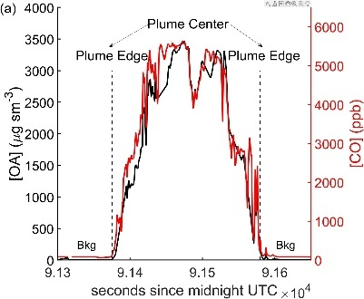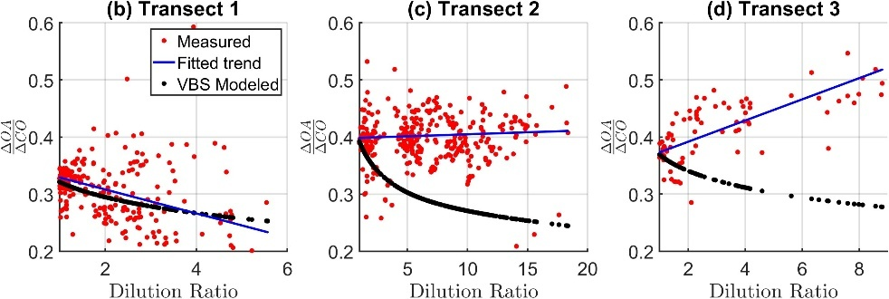

Figure 4. (a) Time series of OA and CO when aircraft intersects a wildfire plume. (b)-(d) Single Transect Analysis (STA) on near-field OA evolution for three representative transects. The red data points represent 1Hz measurements from a single transect and the black dots represent the VBS-modeled ∆OA/∆CO, which is the OA evolution trend due to dilution-driven evaporation. The difference between black and red represents the impact of chemical production on OA evolution.
We propose extending STA to study near-field OA evolution. Figure 4(a) shows time series of CO and OA for an example plume transect in FIREX-AQ. The concentrations of both species peak near the center and decrease toward the edges. In STA, each crosswind transect is treated as an independent plume evolution event, with the plume center (defined by the maximum CO concentration) serving as the initial condition and OA evolves from plume center outward toward the edges.
We will study OA evolution within each plume transect by plotting ΔOA/ΔCO vs. dilution ratio, which serves as a proxy for plume age. ΔOA/ΔCO at each point is calculated using instantaneous concentrations after subtracting background levels estimated from immediately before and after the transect. The dilution ratio is defined as the maximum CO concentration divided by the instantaneous CO concentration. Figure 4(b–d) shows three example transects in this framework. The OA evolution will be quantified by the slope of ∆OA/∆CO as function of dilution ratio (e.g., blue lines in Figure 4(b)). Transect 1 shows a decreasing trend, Transect 2 is relatively stable, and Transect 3 exhibits an increasing trend in ΔOA/ΔCO.
This framework enables separation of dilution-driven evaporation and chemistry-driven SOA formation. The OA loss due to evaporation can be simulated using a VBS model and the dilution ratio. For example, the black dots in Figure 4(b)-(d) show the expected OA evolution based solely on dilution, using a VBS derived from in situ FIREX-AQ measurements¹⁶. The SOA formation is then estimated by subtracting the modeled ΔOA/ΔCO from the observed values (i.e., the difference between red and black dots). In Transect 1, the agreement between model and measurement suggests little SOA formation, whereas in Transects 2 and 3, the observed ΔOA/ΔCO exceeds the modeled value, indicating SOA production.
Overall, the STA provides a novel and powerful framework for studying OA evolution. It captures the diverse behaviors reported in pseudo-Lagrangian studies, as shown by the different trends in different transects (Figure 4). Moreover, STA offers several advantages over the pseudo-Lagrangian analysis. First, it is less sensitive to temporal variability in emissions, since each transect samples smoke emitted over a narrow time window. Second, it significantly increases the sample size. While pseudo-Lagrangian analysis combines multiple transects to yield a single evolution trend per fire, STA treats each transect as an independent event, allowing multiple trends to be extracted from a single fire. In WE-CAN and FIREX-AQ, each campaign includes more than 200 plume transects, providing a strong statistical foundation. Third, STA can separate the roles of dilution and chemical production.
We will quantify OA evolution, OA loss due to evaporation, and SOA formation for each transect in FIREX-AQ and WE-CAN. These metrics will be used to identify the dominant processes driving OA evolution and to evaluate WRF-LES-Chem performance, as discussed in next sections. We will explicitly account for uncertainties in the calculation. For example, multiple sets of VBS parameters for wildfire OA have been reported in the literature; we will test each set to assess the resulting uncertainty in estimated OA evaporation losses. Similarly, we will evaluate the effects of different background determination methods on the ∆OA/∆CO²¹. We will also account the influence of background OA level on the OA evaporation⁵⁶.
While STA offers advantages over traditional pseudo-Lagrangian analyses, it also has inherent limitations and uncertainties. A limitation of STA is that it captures relatively short oxidation timescales compared to pseudo-Lagrangian analysis. However, these timescales are sufficient to form SOA. Our previous analysis of FIREX-AQ data showed that OH exposure can vary by up to 2×10¹⁰ molecules cm⁻³ s between the plume edge and center³³. This is equivalent to roughly 3 hours of downwind aging, assuming an OH concentration of 2×10⁶ molecules cm⁻³. Thus, despite being shorter, the oxidation timescales within individual transects are adequate to produce observable SOA. This is supported by the evolution patterns observed in Transects 2 and 3 in Figure 4, where the SOA production is observable.
One uncertainty in STA analysis is that the plume edge may travel faster than the center, and mixing between the center and edge may occur⁵⁷. We will use the Williams Flats Fire simulation in WRF-LES-Chem to assess STA accuracy. Because the model incorporates both dilution-driven evaporation and chemistry-driven SOA formation, we can directly track these processes via transport and chemical tendency terms in model. We will then apply the STA procedure to the simulated plume to separate these two processes and compare the STA-derived estimates to the “truth” in the LES output. Importantly, our goal is to evaluate the STA method rather than the accuracy of WRF-LES-Chem; therefore, close agreement between the model and field observations is not essential for this analysis.
Task 4.2.2 WRF-LES-Chem. We will leverage WRF-LES-Chem to improve process-level understanding of OA evolution. Our workflow begins by simulating the near-field OA evolution of the Williams Flats Fire, a well-characterized case with extensive observational constraints from FIREX-AQ. We will evaluate the simulation against these field measurements to identify biases and improve model representation of key processes, such as emissions and SOA formation. Once model performance is optimized, we will conduct targeted sensitivity tests to isolate the roles of individual drivers (e.g., oxidant levels, SOA chemistry) and quantify their relative impacts on OA evolution (in Task 4.2.3). This stepwise approach enhances the model’s predictive capability and improves our understanding of OA evolution in the near-field.
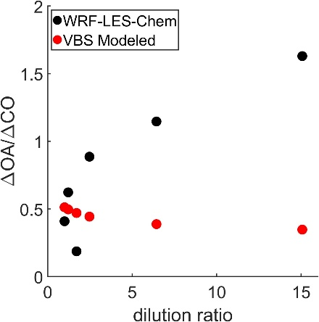
We have conducted a preliminary WRF-LES-Chem simulation using the default setup described in 4.1, with a spatial resolution of 300 m (instead of the proposed 100 m). A plume transect Z h downwind is analyzed with the STA method (Figure Y). The initial ΔOA/ΔCO at the plume center is ~0.5, similar to observations from the Williams Flats Fire. However, simulated SOA formation seems too strong. At a dilution ratio of 15, ΔOA/ΔCO increases by a factor of 3 relative to initial emissions, whereas preliminary analysis of field observations shows much weaker growth. For example, Transect 3 in Figure 4 shows only 25% growth at a dilution ratio of 8. This discrepancy suggests the model overestimates SOA production.
We will systematically evaluate the model performance and address discrepancies between simulations and observations. We will begin by evaluating plume injection height. The LES will be initialized using a fire size of 0.66 km² and a sensible heat flux of 10⁴ W m⁻², which are inferred from the GOES-16 fire detection product and consistent with those used in a previous LES study. The simulated vertical profiles of CO and particulate matter will be compared with those of the aerosol backscatter coefficient at 532 nm measured by NASA’s Differential Absorption Lidar (DIAL) aboard the DC-8, which provide an estimate of plume structure. If discrepancies arise, we will adjust fire size or sensible heat flux to improve agreement.
We will then adjust the emission fluxes of chemical species. Specifically, we will compare modeled concentrations of key gas-phase species (e.g., CO, NO_{x}, HCHO, and O₃) with measurements in both the pseudo-Lagrangian framework and the STA framework. If discrepancies arise, we will adjust the emissions until the modeled results achieve reasonable agreement with measurements.
Figure Z. Single transect analysis on a preliminary WRF-LES-Chem simulation.
The primary objective of adjusting the plume injection height and emission inventory is to minimize the influence of their uncertainties on simulated plume evolution, allowing us to focus on the key question of how chemistry drives plume evolution. We will focus on reconciling model–measurement differences in ΔOA/ΔCO evolution within the STA framework. The comparison shown in Figure Y will be extended to all 20 transects in the Williams Flats Fire sampled on 8/3/2019, as well as to other relevant species. Simulated plumes will be sampled at the same downwind distances as the measured transects to ensure consistent evaluation. We suspect that the overprediction of SOA formation in WRF-LES-Chem is systematic. Potential causes include overestimation of oxidation rates, precursor concentrations, SOA yields, or a combination thereof. We will diagnose contributions of these factors to the overestimation.
We will use the model’s chemical tendency outputs to identify the dominant precursors and oxidants responsible for SOA formation, which will guide the diagnosis. For example, if OH oxidation is identified as the primary pathway, we will compare modeled OH exposure with OH exposure inferred from field measurements to assess the accuracy of simulated oxidation extent. Evaluating the accuracy of modeled SOA precursors is more challenging because the likely dominant contributors, S/LVOCs, are not comprehensively measured in the field and are lumped in the model. To address this, we will use measured SOA precursors, such as phenol, to evaluate the model simulation, even though the measured species only account for a small fraction of the total precursor as shown in Palm et al. We will also use sensitivity tests by adjusting precursor emissions until the model matches observed ΔOA/ΔCO evolution, thereby providing an indirect evaluation of the modeled SOA precursor pool.
Next, we will evaluate the influence of key parameters governing SOA formation in the model, including the OH reaction rate constant, SOA yield, mass increase per oxidation step, oxidant-specific branching ratios, and oxidation state evolution. These parameters, which determine multi-generational aging within the VBS framework, are critical for capturing the competition between functionalization and fragmentation reactions. We will conduct sensitivity tests by perturbing each parameter by a set fraction and assessing the corresponding change in the simulated ΔOA/ΔCO evolution.
The abovementioned tests will reveal which parameter(s) have strong influence on SOA formation, and it is likely that a combination of adjustments will be required to match the model with observations. We will make these adjustments with careful consideration of parameter ranges reported in the literature. For example, reducing SOA yield may be necessary to lower SOA production in the model, but values lower than 10% are unlikely given the properties of S/LVOCs. Once the adjustments are complete, the model will reproduce the observations with reasonable fidelity and will then be used to diagnose the processes and variables controlling OA evolution, as described in the next section.
Task 4.2.3 Analysis of variability in OA evolution. It is generally accepted that near-field OA evolution is governed by the competition between dilution-driven evaporation and chemistry-driven SOA formation. The heterogenous oxidation and photolysis play a lesser role in the near-field. However, multiple variables affect the OA evolution and it is challenging to explain the variability in OA evolution trends. We aim to elucidate the roles of key variables driving OA evolution using STA and a conceptual framework.
In this framework (Figure 5), the OA evolution trend is characterized by two synthetic parameters: OH exposure and SOA formation potential. OH exposure, defined as the time-integrated concentration of OH radicals, represents the extent of photochemical aging. It reflects the influence of solar radiation, aerosol optical extinction, and the abundance of OH precursors such as O₃, HONO, and HCHO. SOA formation potential represents the capacity of gas-phase organics to form SOA upon oxidation. It is calculated using Eqn. (1), where the k, SOA yield, and [C] represent the OH rate constant, SOA yield, and concentration of gas-phase organics. The SOA formation potential depends on both the abundance of SOA precursors and their reactivity (e.g., OH rate constants, SOA yields). The abundance of these precursors is governed by the initial OA concentration and the extent of plume dilution. Notably, SOA formation potential bridges chemistry-driven production and dilution-driven loss. While high SOA formation potential suggests large SOA production upon oxidation, it also implies substantial precursor release via OA evaporation, as most SOA precursors in wildfire plumes originate from evaporated OA¹¹.
$SOA formation potential= \sum_{i=1}^{n}{k_{i}×SOA Yield_{i}×{[C}_{i}]}$ Eqn. (1)
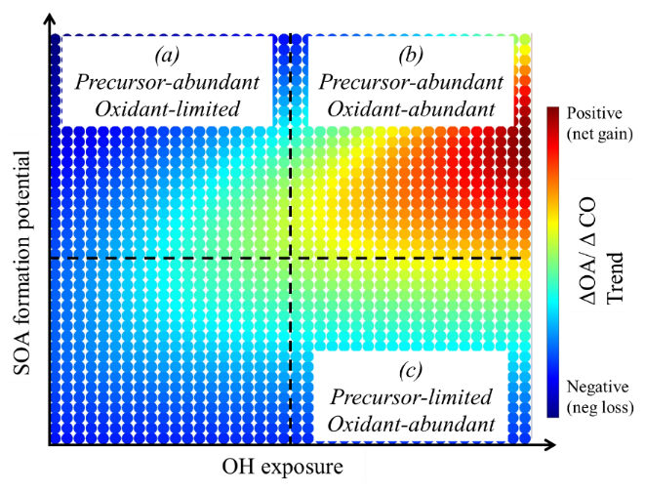
This conceptual framework synthesizes multiple variables into two governing axes that represent the competing processes of production and loss. We will use this framework to interpret the OA evolution. We hypothesize that plume transects will fall into distinct regimes based on the balance between OH exposure and SOA formation potential (Figure 5). (a) In the “Precursor-abundant, Oxidant-limited” regime, we expect net OA loss because dilution-driven evaporation releases a large pool of precursors, but the resulting decrease in OA concentration cannot be offset by SOA formation due to limited OH. (b) As OH exposure increases under similar level of SOA formation potential, the trend should shift toward the “Precursor-abundant, Oxidant-abundant” regime, we expect net OA gain. (c) If SOA formation potential is low or OH exposure is high, the transect may fall into a “Precursor-limited, Oxidant-abundant” regime. We expect net OA loss due to limited precursor availability and thereby insufficient SOA production.
Figure 5. A conceptual framework characterized by OH exposure and SOA formation potential to investigate the variability of OA evolution trends.
We will use both field measurements and WRF-LES-Chem in this framework to evaluate the OA evolution. The idea is similar to studying ozone chemistry where ambient measurements are placed on a VOC-NOx-O3 isopleth generated by a box model. Here, for each transect, we will quantify three key parameters: OA evolution trend, OH exposure, and SOA formation potential. These three parameters can be readily calculated in WRF-LES-Chem. We can achieve a range of OH exposure and SOA formation potential to create the contour plot in Figure 5, by changing the parameters in WRF-LES-Chem, such as dilution ratio, OH concentration, or SOA yield.
We will also quantify these three parameters using field measurements. The quantification of OA evolution has been described above (e.g., blue lines in Figure 4(b)). We will calculate OH exposure from the change in phenol/benzene ratio between plume center and edge. This approach has been validated in our previous FIREX-AQ analysis and will be applied consistently to the WE-CAN dataset. Due to the lack of comprehensive measurements of SOA precursors, we will estimate SOA formation potential using the initial OA concentration, dilution ratio, and OA VBS. Specifically, we will dilute the maximum OA concentration in each transect by the maximum dilution ratio and use equilibrium assumptions with the wildfire OA VBS to estimate the abundance and volatility distribution of gas-phase organics. Surrogate compounds will be assigned to each volatility bin, and their reaction rates and SOA yields will be estimated. While SOA yield depends on multiple factors (e.g., absorbing mass, peroxy radical fate), we will assume it to be constant within each bin for this analysis.
We will conduct a comprehensive uncertainty analysis. First, a key assumption in above analysis is that SOA is produced mainly through OH oxidation; however, previous studies suggest that O₃ and NO₃ oxidation may be significant in thick plumes^{58, 59}. We will use WRF-LES-Chem to assess the relative importance of these pathways. Second, the SOA formation potential derived from field data carries large uncertainties. We will begin with the simple assumption of a constant SOA yield and then progressively incorporate additional complexities, such as the effects of OA concentration and NOx on SOA yield. Third, the choice of surrogate compounds for each VBS bin introduces uncertainty. To evaluate this, we will conduct sensitivity tests by varying the OH reaction rate constants and SOA yields within reasonable ranges and propagating these variations into the final estimates of SOA formation potential.
Overall, this approach provides a coherent and testable framework to explain the observed variability in OA evolution. The framework distills the complex variable space into two synthetic parameters and identifies controlling factors under different fire and atmospheric conditions. The large number of transects sampled in WE-CAN and FIREX-AQ provide a strong statistical foundation for the proposed analysis.

4.3 Investigate the evolution of organic aerosol during long-range transport

Questions: How does OA evolve during long-range transport, and what factors influence its evolution during long-range transport?
Task 4.3.1. Quantify the OA evolution using field data. We will leverage measurements from five field campaigns to quantify the OA evolution over long-range transport. A key limitation in comparing the measured ΔOA/ΔCO (denoted as (ΔOA/ΔCO)_{measured}) from different fires is that they could have different values of initially emitted ΔOA/ΔCO (denoted as (ΔOA/ΔCO)_{emitted}). We propose to address this limitation by developing a parameterization that relates (ΔOA/ΔCO)_{emitted} to a plume metric. (ΔOA/ΔCO)_{emitted} can then be estimated in aged plumes based on the observed value of the metric and the parameterization.
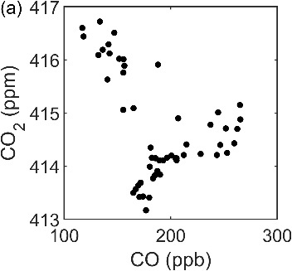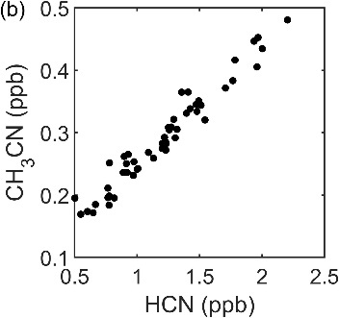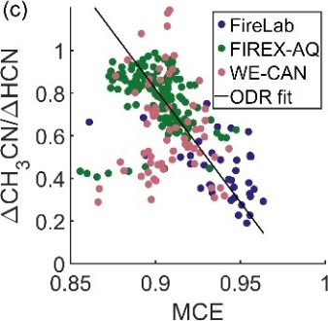
Figure 6. (a) No clear correlation between CO and CO₂ in an aged AEROMMA plume transported for ~4 days. (b) Correlation between CH₃CN and HCN for the same transect shown in panel (a). (c) Relationship between CH₃CN/HCN and MCE. Each point represents a crosswind transect from airborne measurements or laboratory stack burn experiments from 2016 FireLab campaign.
The modified combustion efficiency (MCE), defined as ΔCO₂/(ΔCO+ΔCO₂), is widely used to parameterize emission ratios or emission factors^{68–70}. However, MCE is not applicable here because MCE in aged smoke is difficult to quantify due to elevated and variable background levels of CO and CO₂⁷¹ (e.g. Figure 6(a)). BC to CO ratios have also been used as a proxy for combustion efficiency, but differences in phase (BC in particle vs CO in gas) result in their different loss pathways during transport. We propose using the ΔCH₃CN/ΔHCN ratio as the basis for parameterizing (ΔOA/ΔCO)_{emitted}. This choice is supported by several factors: (1) both CH₃CN and HCN are tracers for wildfire emissions; (2) their primary removal pathway in the free troposphere is reaction with OH and their lifetimes can exceed one year, ensuring strong correlation even in aged plumes (Figure 6(b)); (3) their ratio is related to MCE as shown in Figure 6(c).
Our previous work has successfully parameterized the emission ratios of brown carbon absorption, toluene, benzene, and phenol as functions of ΔCH₃CN/ΔHCN³². Here, we propose extending this approach to OA. Ideally, such parameterization would be derived using laboratory experiments with minimal atmospheric processing. However, AMS data were not collected during the 2016 FIREX-FireLab stack burns, and earlier laboratory datasets either lack necessary measurements (e.g., CH₃CN and HCN) or are difficult to access. Thus, we will parameterize (ΔOA/ΔCO)_{emitted} as a function ΔCH₃CN/ΔHCN using near-field measurements from FIREX-AQ and WE-CAN. Although OA has undergone aging during the first few hours after emission, the (ΔOA/ΔCO)_{measured} values from these campaigns are reasonable proxies for (ΔOA/ΔCO)_{emitted} when applied to aged plumes with multi-day transport times (e.g., AEROMMA).
Figure 7 presents our preliminary analysis of the relationship between ΔOA/ΔCO and ΔCH₃CN/ΔHCN. Each data point corresponds to a single crosswind transect, and only transects with physical ages less than 3 hours are included. Future work will focus on improving the selection criteria for transects used in the parameterization and developing a quantitative parameterization of the relationship using data binning or smoothing techniques. We acknowledge that some variability in ΔOA/ΔCO exists at a given ΔCH₃CN/ΔHCN. This variability represents the uncertainty in the estimated (ΔOA/ΔCO)_{emitted} and will be propagated through the subsequent analysis.
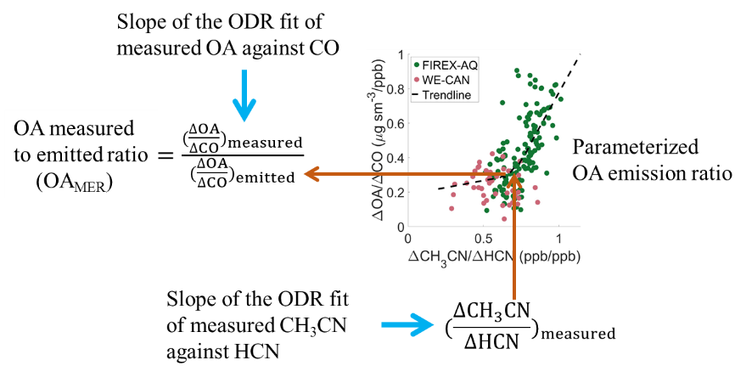
The derived parameterization will be applied to estimate the (ΔOA/ΔCO)_{emitted} of aged wildfire plumes and investigate the OA evolution. Specifically, we will (1) use measurements of CH₃CN and HCN in aged plumes to calculated (ΔCH₃CN/ΔHCN)_{measured}, (2) use it to estimate the (ΔOA/ΔCO)_{emitted}, and (3) normalize (ΔOA/ΔCO)_{measured} by (ΔOA/ΔCO)_{emitted} to derive the OA Measured-to-Emitted Ratio (OA_{MER}). OA_{MER} quantifies the fraction of OA remaining after atmospheric aging. This method enables consistent cross-study comparisons and accurate interpretation of OA evolution in wildfire plumes.
A key assumption in our approach is that the parameterization of OA emission ratios derived from WE-CAN and FIREX-AQ is broadly representative of fuel types sampled in other field campaigns. This assumption is reasonable for SEAC⁴RS and MBO-2019, which primarily sampled wildfires originating in the western U.S., a region well studied in WE-CAN and FIREX-AQ. However, the parameterization may be less accurate for aged plumes sampled in AEROMMA, many of which originated from Canada, where key fuels include spruce-lichen woodlands, boreal spruce, lodgepole pine, conifer plantations, ponderosa pine, and Douglas fir. While some of these fuel types were sampled in WE-CAN and FIREX-AQ, coverage is incomplete. Given the limited existing measurements, our proposed approach represents the best available method to estimate (ΔOA/ΔCO)_{emitted} for aged Canadian plumes.

Figure 7. Parameterization of OA emission ratio. Each point represents a crosswind transect. A flowchart illustrating the calculation of OA measured-to-Emitted ratio (OA_{MER}).
We will assess OA evolution by plotting OA_{MER} as a function of OH exposure. The OA_{MER} accounts for variability in emission ratios and allows for a more consistent comparison of OA evolution across different fires. We choose OH exposure, rather than physical plume age, as OH exposure better represents photochemical processing. Key processes such as SOA formation, heterogeneous OH oxidation, and OA photolysis are all related to OH exposure, though their dependencies are complex. OH exposure is estimated by comparing observed ratios of selected VOCs (e.g., Δphenol/Δbenzene, Δtoluene/ΔHCN, and Δbenzene/ΔHCN) with their emission ratios. This method has been successfully applied to WE-CAN, FIREX-AQ, SEAC⁴RS, and AEROMMA in our previous analyses of brown carbon evolution³² and will be extended to MBO-2019.
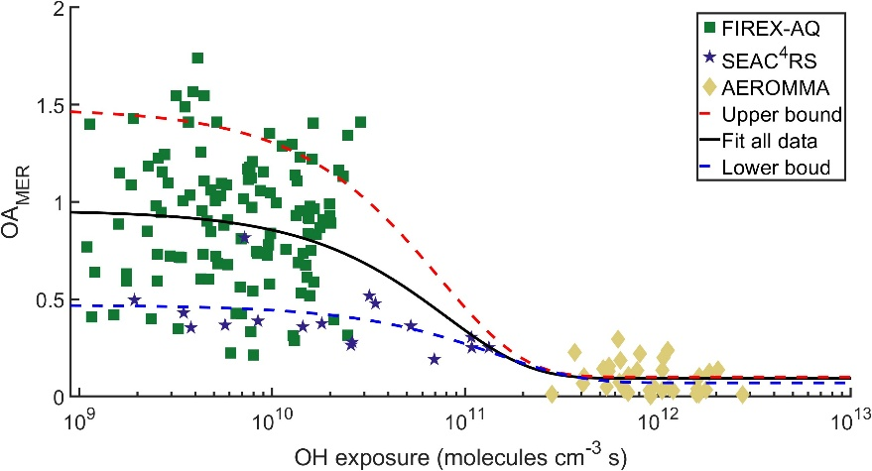
As shown in Figure 9, our preliminary analysis indicates that OA_{MER} decreases with increasing OH exposure. We will expand the analysis to include data from WE-CAN and MBO. We will quantitatively describe OA evolution by fitting the OA_{MER} vs. OH exposure relationship using an exponential decay model, assuming first-order decay. This fitting result may be used in regional models to represent wildfire OA evolution. We will conduct comprehensive sensitivity and uncertainty analyses to account for uncertainty in the measurements, the observed variability of OA_{MER} in the near-field, the uncertainty in the estimated emission ratios. For example, we will apply weighted least squares regression to incorporate the propagated uncertainties of individual data points. To estimate bounds on the decay rate, we will perform fits using only the lower or upper 25th percentiles of FIREX-AQ data (represented by the blue and red lines in Figure 9, respectively). Given there are more measurements in the near-field than far-field, we may include campaign-specific weighting to account for differences in sample sizes across datasets. In this approach, individual points from FIREX-AQ and WE-CAN are assigned lower weights than those from SEAC⁴RS or AEROMMA. Finally, we will compare our results with previous field and modeling studies. To enable comparison with studies that use transport time, we will assume a range of OH concentrations to convert transport time into OH exposure.
Figure 9. Preliminary analysis on OA evolution using data from FIREX-AQ, SEAC⁴RS, and AEROMMA.
Task 4.3.2 Quantify OA evolution using regional modeling. We will simulate the OA evolution during long-range transport using mesoscale WRF-Chem with using a three-domain (D01-D03) and D03 having ~1 km horizontal resolution. The basic modeling configuration has been described in Task 4.1.2. We will conduct two regional WRF-Chem simulations: 1) including all emissions with fire and non-fire sources, and 2) excluding fire emissions only. This approach will allow us to separate the specific impacts of fire and examine OA evolution within fire plumes. Simulations will cover an intracontinental domain for July-August in 2019 and 2023, overlapping with the 2019 FIREX-AQ and 2023 AEROMMA campaign.
We will first evaluate model performance by comparing the simulated chemical concentrations and meteorological fields from the all-emission simulation to AEROMMA observations. We will extract model results according to the coordinates of AEROMMA measurements, which include both wildfire plumes and vertical profiles during spiral. We will start the evaluation with several widely used biomass burning tracers—BC, CO, CH₃CN, and HCN. These tracers are inert and stay in different phases, providing a robust basis for evaluating the accuracy of FINN emissions. The adjusted FINN emission based on near-field study (Task 4.2.2) will be used as a starting point, but further adjustments may be needed to match model with measurements for long-range transport. We will also use the field-derived parameterization of OA emission ratio (Figure 7) to evaluate the FINN emission inventories. For each species, FINN produces daily global gridded emissions at 1 km resolution, calculated as the product of burned area, fuel load, combustion completeness, and the emission factor. For each wildfire identified during the campaign, we will extract FINN emissions to compute emitted ratios, CH₃CN/HCN and OA/CO, over the burned grid cells. Their relationship in FINN will be compared with those derived from in-situ measurements (Figure 7).
The plume injection height may also need tuning. To improve the representation of plume injection heights in regional modeling, we will leverage the LES-based results from Task 4.2.2. Specifically, we will develop a relationship between surface energy and vertical injection height, and use this relationship to allocate the fraction of emissions across vertical layers. This will provide a more realistic emission profile in regional simulations. For this enhancement, we will also reference Wang et al. (2024), which implements [XX] to correct plume injection profiles. Finally, the scaled FINN inventory and plume injection height will then be used in all-emissions simulations to produce more realistic results.
After model evaluation and adjustment, we will use model results to reproduce the OA–OH exposure relationship shown in Figure 9. The key objective is to simulate the general OA evolution for any fire, instead of comparing to specific field measurements. We will analyze the 4-D WRF-Chem simulation results (Eulerian framework) in a Lagrangian framework. By subtracting the no-fire simulation from the all-emission simulation with updated emissions, we isolate fire impacts and obtain ΔOA, ΔCO, ΔCH₃CN, and ΔHCN, consistent with the variables used in the observational analysis. To define smoke boundaries, we will use the 90th percentile concentrations of the four fire-characteristic tracers—BC, CO, CH₃CN, and HCN. Smoke regions will be identified from the spatial overlap of these four tracers. For each grid cell within the defined smoke boundaries, we will relate OA/CO ratios to OH exposure to derive OA evolution curves. Because we track the same plume parcel from emission from downwind, the OAMER can be easily calculated. The OH exposure can be calculated by the OH concentration times the time step in each grid.
The OA evolution derived from modeling will be compared to the measurement to identify misrepresented processes and understand the processes driving the OA evolution during long-range transport (Task 4.3.3).
Task 4.3.3 Understand processes driving the OA evolution. OA evolution is influenced by multiple processes, including dilution-driven evaporation, SOA formation, wet and dry deposition, heterogeneous oxidation, and photolysis. To evaluate the relative importance of these processes along a long-range transport, we will integrate analysis of field measurements with WRF-Chem sensitivity simulations.
We hypothesize that after several days of transport, SOA precursors are largely depleted, and SOA formation becomes negligible. We will test this hypothesis using comprehensive measurements of aged wildfire plumes from the AEROMMA campaign. A key diagnostic is the measured OH reactivity (OHR), which represents the inverse lifetime of OH and serves as a proxy for the total amount of reactive gas-phase compounds⁶⁰. We will calculate the contribution of measured species to OHR and attribute the residual to unmeasured compounds. Preliminary analysis shows that the combined contribution of CO, CH₄, HCHO, and inorganic species accounts for 80% of the measured OHR in aged wildfire plumes. Furthermore, the measured OHR in aged plumes is comparable to that of background air. These findings support the hypothesis that aged wildfire plumes are largely depleted in SOA precursors.
To further characterize the gas-phase composition of aged plumes, we will analyze data from PTR-MS, NH₄⁺ CIMS, and CF₃O⁻ CIMS, which together span a broad range of organic compound volatilities. In addition to archived species in the AEROMMA database, we will examine the raw mass spectra to identify additional compounds with enhanced signals in aged wildfire plumes. PI Xu already has the raw PTR-MS, NH₄⁺ CIMS and CF₃O⁻ CIMS datasets.
We hypothesize that heterogeneous oxidation significantly influences OA evolution, but its impact is underestimated in current models due to a low reactive uptake coefficient (γ). Sedlacek et al. showed that applying γ values derived from laboratory flow-tube experiments significantly overpredicted BC coating thickness, a proxy for SOA formation, in wildfire plumes. In contrast, Zhang et al. demonstrated that γ values can increase by 2–3 orders of magnitude when experiments are conducted under atmospherically relevant OH concentrations, compared to the flow-tube experiments under elevated OH concentrations. This suggests that heterogeneous oxidation may be substantially more efficient than assumed in models.
To evaluate the role of heterogeneous oxidation, we will conduct sensitivity simulations in WRF-Chem by varying γ, from 0, 10⁻⁵, 10⁻³, to 0.1, to quantify its influence on ∆OA/∆CO. Measurements such as for semi-solid/viscous OA typically give small γ values, e.g., 10⁻⁶–10⁻³, because bulk diffusion limits reaction or the condensed phase is less reactive, but the values often depend on experimental conditions and can vary by orders of magnitude. We hypothesize that the default WRF-Chem configuration overpredicts ∆OA/∆CO during long-range transport. A substantially larger γ value is likely required to match field observations. This analysis will help constrain the uncertainty in reactive uptake of OH and its contribution to OA aging.
Dilution-driven evaporation will be represented in WRF-Chem using the VBS approach. We will test three VBS parameterizations: the WRF-Chem default, one derived from FIREX-AQ in situ data, and one from laboratory experiments. We hypothesize that differences among these have minor effects on OA evolution, as suggested by Pagonis et al. To assess photolytic loss of OA, we will conduct sensitivity simulations by varying photolysis rates within ranges reported in the literature, e.g., for a low photolysis scenario with ~1x10⁻⁶ s⁻¹, moderate case with 1x10⁻⁵ s⁻¹, and a high photolysis scenario with 1x10⁻⁴ s⁻¹. Photolysis is expected to play a smaller role than heterogeneous oxidation, as lab studies show only ~20% of BBOA mass is lost after several days of photochemical aging, but it can still drive important changes in optical properties and chemical composition. OA deposition will not be studied in this project. We will exclude plume transects likely influenced by cloud processing, identified based on indicators such as lower dew point temperatures, reduced concentrations of soluble gases or aerosol volume, or nucleation mode presence in particle size distributions.
Using most appropriate values of γ and photolysis obtained from laboratory experiments or literature, we will perform a summary sensitivity simulation to examine the combined impacts of these adjusted values. Based on these simulation results, we can output the chemical and physical diagnostics for OA evolution, same as presented in previous tasks, to separate primary and secondary OA, identify key SOA precursors and major chemical pathways, and evaluate the impacts of dilution-driven evaporation, wet deposition, and het oxidation, photolysis on OA evolution. Overall, this allows us to evaluate process-based modeling and improve representations of these processes in the model.

4.4 Summary
Our proposed work will answer pivotal questions to decipher the evolution of OA in wildfire plumes across diverse spatial scales. Our proposed activities will leverage measurements from five major field campaigns and further integrate them with atmospheric modeling. In Section 4.1, we aim to elucidate the factors contributing to the variability in the near-field evolution of OA. We will deploy a novel single transect analysis that examines plume composition variations across a single crosswind transect. This method is less sensitive to variability in emissions compared to the traditional pseudo-Lagrangian analysis. Using a conceptual framework based on OH exposure and SOA formation potential, we will explore the interplay between dilution-driven evaporation and SOA formation. In Section 4.3, we aim to characterize OA evolution during long-range transport. By compiling data from multiple field campaigns, we will quantify OA evolution, after accounting for variability in emission ratios, as a function of OH exposure. We will focus on investigating the roles of SOA formation and heterogeneous oxidation on OA evolution, using detailed observations of aged plumes from AEROMMA and sensitivity simulations in WRF-Chem. Together, these efforts will provide a coherent and mechanistic understanding of the chemical evolution of OA in wildfire plumes from the fire source to thousands of kilometers downwind.

5. General Work Plan and Deliverables
The overall project schedule and tasks are outlined in Table 5-1. The experimental analysis will be led by PI Xu and a graduate student at the Washington University in St. Louis. The modeling analysis will be led by PI Li and a graduate student at the Baylor University. PIs Xu and Li will be responsible for the overall management of the project and will organize biweekly meetings for the project team. We will also attend the same conferences to facilitate in-person collaboration and to maximize the efficiency of travel resources.
Table 5-1. General work plan.
Obj. | Tasks | Year 1 |  |  |  | Year 2 |  |  |  | Year 3
Obj. | Tasks | 1 | 2 | 3 | 4 | 1 | 2 | 3 | 4 | 1 | 2 | 3 | 4
1 | Quantify OA evolution using Single Transect Analysis
1 | Simulate Williams Flats Fire using WRF-LES-Chem
1 | Analyze variability of OA evolution
2 | Quantify OA_{MER} vs. OH exposure using field data
2 | Conduct WRF-Chem to simulate OA evolution
2 | Diagnose key processes affecting OA evolution

6. Broader Impacts

6.1 Student mentoring
This collaborative proposal will support two PhD students, one at Washington University in St. Louis (WUStL) and one at Baylor University. Both students will be co-advised by PIs Xu and Li. The primary objective is to nurture individuals with profound expertise in both experimental and modeling aspects. Each PI will advise one undergraduate student during summer internships. To enhance collaboration, we will organize biweekly meetings and arrange annual visits between the two institutions. The PIs plan to deliver guest lectures at each other's classes. This structured approach seeks to enrich the educational experience and create a dynamic exchange of knowledge between the two institutions.

6.2 Outreach to enhance public education
The surge in extreme wildfire events in recent years has raised significant awareness about the severity of wildfires among the public. Notably, the unprecedented Canadian wildfires in 2023 blanketed the northeastern and midwestern U.S. and led to dangerous air quality. Capitalizing on this heightened awareness, the PIs will collaborate on developing and implementing outreach activities to foster a better understanding of wildfire science among the public. The initiative involves creating informative slides that explain the wildfire science, how wildfires impact air quality, and how climate change intensifies wildfires. These slides will feature captivating atmospheric modeling animations and wildfire videos taken during the FIREX-AQ campaign. In addition to presentations, we will incorporate hands-on experiments to elucidate wildfire behaviors. For instance, we will generate flaming and smoldering conditions by simply using candle experiments, allowing students and the public to observe the resulting plumes. At Baylor, PI Li’s group will build upon previous outreach efforts (e.g., Meet the Scientist, National Stem Day) and continue working with Baylor University’s Mayborn Museum on the design, execution, evaluation, and revision of outreach events. Mayborn Museum receives 180,000 visitors annually and is accredited by the American Alliance of Museums. PI Li’s group members will undergo half-day training sessions in communicating science to the public through the Mayborn’s Portal to the Public Program (NSF-funded #0639021 and #1224129). After the training, the lab will present at two events each year at the Mayborn which are aimed at K-12 students and their parents. At WUStL, Xu's group will work with the Washington University Institute for School Partnership (ISP) to provide workshops and tours to K-12 teachers in the St. Louis area. ISP programs serve approximately 180,000 students and 3,800 educators, and 74% of our partner districts have greater than 40% free & reduced lunch participation and/or qualify for the community eligibility provision (CEP) program. PI Xu will present outreach materials in the "Hot Topics" seminars and workshops for middle and high school teachers organized by the ISP. Additionally, students, teachers, and parents will be invited to tour the PIs’ lab, providing an opportunity to captivate young minds with easily accessible and visually appealing information. To maximize the collaborative efforts, the PIs will coordinate at least two public presentations together at each other’s institutions during the grant period.

7. Results from Prior NSF Support for Funded Investigators
Yang Li: (a) CIVIC-2322319, $1,015,999, 10/1/2023 – 09/30/2025. (b) “SCC-CIVIC-FA Track A: Novel Fuel-Flexible Combustion to Enable Ultra-Clean and Efficient Waste-to-Renewable Energy in Changing Climate.” (c) Intellectual Merit: developing complete combustion for landfill gas flare and waste-based biofuels to realize zero emissions of methane and air pollutants; modeling the impacts of the novel technology on air quality, global warming, and economic benefits. Broader impacts: This grant supports three Ph.D. students, two postdoctoral researchers, and two undergraduate students, and also are enhancing public education through multiple outreach events. (d) A paper “Assessing Climate Benefits of Methane Mitigation for U.S. Landfills” is under review. (e) Evidence of research products and their availability include well-documented combustion data and climate-modeling results, as well as recorded videos for previously hosted outreach events that can be used for curriculum development. (f) Not applicable.
Lu Xu: No prior support.

References
(1) Iglesias, V.; Balch, J. K.; Travis, W. R. U.S. fires became larger, more frequent, and more widespread in the 2000s. Science Advances 2022, 8 (11), eabc0020. DOI: doi:10.1126/sciadv.abc0020.
(2) Burke, M.; Childs, M. L.; de la Cuesta, B.; Qiu, M.; Li, J.; Gould, C. F.; Heft-Neal, S.; Wara, M. The contribution of wildfire to PM2.5 trends in the USA. Nature 2023. DOI: 10.1038/s41586-023-06522-6.
(3) McClure, C. D.; Jaffe, D. A. US particulate matter air quality improves except in wildfire-prone areas. Proceedings of the National Academy of Sciences 2018, 115 (31), 7901-7906. DOI: 10.1073/pnas.1804353115.
(4) de Gouw, J. A.; Warneke, C.; Stohl, A.; Wollny, A. G.; Brock, C. A.; Cooper, O. R.; Holloway, J. S.; Trainer, M.; Fehsenfeld, F. C.; Atlas, E. L.; et al. Volatile organic compounds composition of merged and aged forest fire plumes from Alaska and western Canada. Journal of Geophysical Research: Atmospheres 2006, 111 (D10). DOI: 10.1029/2005jd006175.
(5) DeBell, L. J.; Talbot, R. W.; Dibb, J. E.; Munger, J. W.; Fischer, E. V.; Frolking, S. E. A major regional air pollution event in the northeastern United States caused by extensive forest fires in Quebec, Canada. Journal of Geophysical Research: Atmospheres 2004, 109 (D19). DOI: https://doi.org/10.1029/2004JD004840.
(6) Wotawa, G.; Trainer, M. The Influence of Canadian Forest Fires on Pollutant Concentrations in the United States. Science 2000, 288 (5464), 324-328. DOI: 10.1126/science.288.5464.324.
(7) Hung, W.-T.; Lu, C.-H.; Alessandrini, S.; Kumar, R.; Lin, C.-A. The impacts of transported wildfire smoke aerosols on surface air quality in New York State: A multi-year study using machine learning. Atmospheric Environment 2021, 259, 118513. DOI: https://doi.org/10.1016/j.atmosenv.2021.118513.
(8) Alvarado, L. M. A.; Richter, A.; Vrekoussis, M.; Hilboll, A.; Kalisz Hedegaard, A. B.; Schneising, O.; Burrows, J. P. Unexpected long-range transport of glyoxal and formaldehyde observed from the Copernicus Sentinel-5 Precursor satellite during the 2018 Canadian wildfires. Atmos. Chem. Phys. 2020, 20 (4), 2057-2072. DOI: 10.5194/acp-20-2057-2020.
(9) Teakles, A. D.; So, R.; Ainslie, B.; Nissen, R.; Schiller, C.; Vingarzan, R.; McKendry, I.; Macdonald, A. M.; Jaffe, D. A.; Bertram, A. K.; et al. Impacts of the July 2012 Siberian fire plume on air quality in the Pacific Northwest. Atmos. Chem. Phys. 2017, 17 (4), 2593-2611. DOI: 10.5194/acp-17-2593-2017.
(10) Li, Y.; Mickley, L. J.; Liu, P.; Kaplan, J. O. Trends and spatial shifts in lightning fires and smoke concentrations in response to 21st century climate over the national forests and parks of the western United States. Atmos. Chem. Phys. 2020, 20 (14), 8827-8838. DOI: 10.5194/acp-20-8827-2020.
(11) Palm, B. B.; Peng, Q.; Fredrickson, C. D.; Lee, B. H.; Garofalo, L. A.; Pothier, M. A.; Kreidenweis, S. M.; Farmer, D. K.; Pokhrel, R. P.; Shen, Y.; et al. Quantification of organic aerosol and brown carbon evolution in fresh wildfire plumes. Proc Natl Acad Sci U S A 2020, 117 (47), 29469-29477. DOI: 10.1073/pnas.2012218117.
(12) Pye, H. O. T.; Xu, L.; Henderson, B. H.; Pagonis, D.; Campuzano-Jost, P.; Guo, H.; Jimenez, J. L.; Allen, C.; Skipper, T. N.; Halliday, H. S.; et al. Evolution of Reactive Organic Compounds and Their Potential Health Risk in Wildfire Smoke. Environ Sci Technol 2024, 58 (44), 19785-19796. DOI: 10.1021/acs.est.4c06187.
(13) Verma, V.; Fang, T.; Xu, L.; Peltier, R. E.; Russell, A. G.; Ng, N. L.; Weber, R. J. Organic Aerosols Associated with the Generation of Reactive Oxygen Species (ROS) by Water-Soluble PM2.5. Environ Sci Technol 2015, 49 (7), 4646-4656. DOI: 10.1021/es505577w.
(14) Li, Y.; Fu, T.-M.; Yu, J. Z.; Zhang, A.; Yu, X.; Ye, J.; Zhu, L.; Shen, H.; Wang, C.; Yang, X.; et al. Nitrogen dominates global atmospheric organic aerosol absorption. Science 2025, 387 (6737), 989-995. DOI: doi:10.1126/science.adr4473.
(15) Pardo, M.; Li, C.; Zimmermann, R.; Rudich, Y. Health impacts of biomass burning aerosols: Relation to oxidative stress and inflammation. Aerosol Sci Tech, 1-21. DOI: 10.1080/02786826.2024.2379551.
(16) Pagonis, D.; Selimovic, V.; Campuzano-Jost, P.; Guo, H.; Day, D. A.; Schueneman, M. K.; Nault, B. A.; Coggon, M. M.; DiGangi, J. P.; Diskin, G. S.; et al. Impact of Biomass Burning Organic Aerosol Volatility on Smoke Concentrations Downwind of Fires. Environ Sci Technol 2023, 57 (44), 17011-17021. DOI: 10.1021/acs.est.3c05017.
(17) Akherati, A.; He, Y.; Garofalo, L. A.; Hodshire, A. L.; Farmer, D. K.; Kreidenweis, S. M.; Permar, W.; Hu, L.; Fischer, E. V.; Jen, C. N.; et al. Dilution and photooxidation driven processes explain the evolution of organic aerosol in wildfire plumes. Environmental Science: Atmospheres 2022, 2 (5), 1000-1022, 10.1039/D1EA00082A. DOI: 10.1039/D1EA00082A.
(18) He, Y.; Zhao, B.; Wang, S.; Valorso, R.; Chang, X.; Yin, D.; Feng, B.; Camredon, M.; Aumont, B.; Dearden, A.; et al. Formation of secondary organic aerosol from wildfire emissions enhanced by long-time ageing. Nature Geoscience 2024. DOI: 10.1038/s41561-023-01355-4.
(19) Robinson, M. A.; Decker, Z. C. J.; Barsanti, K. C.; Coggon, M. M.; Flocke, F. M.; Franchin, A.; Fredrickson, C. D.; Gilman, J. B.; Gkatzelis, G. I.; Holmes, C. D.; et al. Variability and Time of Day Dependence of Ozone Photochemistry in Western Wildfire Plumes. Environ Sci Technol 2021, 55 (15), 10280-10290. DOI: 10.1021/acs.est.1c01963.
(20) Liao, J.; Wolfe, G. M.; Hannun, R. A.; St. Clair, J. M.; Hanisco, T. F.; Gilman, J. B.; Lamplugh, A.; Selimovic, V.; Diskin, G. S.; Nowak, J. B.; et al. Formaldehyde evolution in US wildfire plumes during the Fire Influence on Regional to Global Environments and Air Quality experiment (FIREX-AQ). Atmos. Chem. Phys. 2021, 21 (24), 18319-18331. DOI: 10.5194/acp-21-18319-2021.
(21) Garofalo, L. A.; Pothier, M. A.; Levin, E. J. T.; Campos, T.; Kreidenweis, S. M.; Farmer, D. K. Emission and Evolution of Submicron Organic Aerosol in Smoke from Wildfires in the Western United States. ACS Earth and Space Chemistry 2019, 3 (7), 1237-1247. DOI: 10.1021/acsearthspacechem.9b00125.
(22) Peng, Q.; Palm, B. B.; Fredrickson, C. D.; Lee, B. H.; Hall, S. R.; Ullmann, K.; Weinheimer, A. J.; Levin, E.; DeMott, P.; Garofalo, L. A.; et al. Direct Constraints on Secondary HONO Production in Aged Wildfire Smoke From Airborne Measurements Over the Western US. Geophysical Research Letters 2022, 49 (15), e2022GL098704. DOI: https://doi.org/10.1029/2022GL098704.
(23) Peng, Q.; Palm, B. B.; Melander, K. E.; Lee, B. H.; Hall, S. R.; Ullmann, K.; Campos, T.; Weinheimer, A. J.; Apel, E. C.; Hornbrook, R. S.; et al. HONO Emissions from Western U.S. Wildfires Provide Dominant Radical Source in Fresh Wildfire Smoke. Environ Sci Technol 2020, 54 (10), 5954-5963. DOI: 10.1021/acs.est.0c00126.
(24) Akagi, S. K.; Craven, J. S.; Taylor, J. W.; McMeeking, G. R.; Yokelson, R. J.; Burling, I. R.; Urbanski, S. P.; Wold, C. E.; Seinfeld, J. H.; Coe, H.; et al. Evolution of trace gases and particles emitted by a chaparral fire in California. Atmos. Chem. Phys. 2012, 12 (3), 1397-1421. DOI: 10.5194/acp-12-1397-2012.
(25) Yokelson, R. J.; Crounse, J. D.; DeCarlo, P. F.; Karl, T.; Urbanski, S.; Atlas, E.; Campos, T.; Shinozuka, Y.; Kapustin, V.; Clarke, A. D.; et al. Emissions from biomass burning in the Yucatan. Atmos. Chem. Phys. 2009, 9 (15), 5785-5812. DOI: 10.5194/acp-9-5785-2009.
(26) Wiggins, E. B.; Soja, A. J.; Gargulinski, E.; Halliday, H. S.; Pierce, R. B.; Schmidt, C. C.; Nowak, J. B.; DiGangi, J. P.; Diskin, G. S.; Katich, J. M.; et al. High Temporal Resolution Satellite Observations of Fire Radiative Power Reveal Link Between Fire Behavior and Aerosol and Gas Emissions. Geophysical Research Letters 2020, 47 (23), e2020GL090707. DOI: https://doi.org/10.1029/2020GL090707.
(27) Warneke, C.; Schwarz, J. P.; Dibb, J.; Kalashnikova, O.; Frost, G.; Al-Saad, J.; Brown, S. S.; Brewer, W. A.; Soja, A.; Seidel, F. C.; et al. Fire Influence on Regional to Global Environments and Air Quality (FIREX-AQ). Journal of Geophysical Research: Atmospheres 2023, 128 (2), e2022JD037758. DOI: https://doi.org/10.1029/2022JD037758.
(28) Sedlacek, A. J., III; Lewis, E. R.; Onasch, T. B.; Zuidema, P.; Redemann, J.; Jaffe, D.; Kleinman, L. I. Using the Black Carbon Particle Mixing State to Characterize the Lifecycle of Biomass Burning Aerosols. Environ Sci Technol 2022, 56 (20), 14315-14325. DOI: 10.1021/acs.est.2c03851.
(29) Collier, S.; Zhou, S.; Onasch, T. B.; Jaffe, D. A.; Kleinman, L.; Sedlacek, A. J., III; Briggs, N. L.; Hee, J.; Fortner, E.; Shilling, J. E.; et al. Regional Influence of Aerosol Emissions from Wildfires Driven by Combustion Efficiency: Insights from the BBOP Campaign. Environ Sci Technol 2016, 50 (16), 8613-8622. DOI: 10.1021/acs.est.6b01617.
(30) Farley, R.; Bernays, N.; Jaffe, D. A.; Ketcherside, D.; Hu, L.; Zhou, S.; Collier, S.; Zhang, Q. Persistent Influence of Wildfire Emissions in the Western United States and Characteristics of Aged Biomass Burning Organic Aerosols under Clean Air Conditions. Environ Sci Technol 2022, 56 (6), 3645-3657. DOI: 10.1021/acs.est.1c07301.
(31) Farley, R.; Zhou, S.; Collier, S.; Jiang, W.; Onasch, T. B.; Shilling, J. E.; Kleinman, L.; Sedlacek Iii, A. J.; Zhang, Q. Chemical Evolution of Biomass Burning Aerosols across Wildfire Plumes in the Western U.S.: From Near-Source to Regional Scales. ACS ES&T Air 2025. DOI: 10.1021/acsestair.5c00002.
(32) Chen, J.-H.; Puttu, U.; Huynh, H. N.; Ahern, A. T.; Ball, K.; Bates, K. H.; Brock, C. A.; Campos, T.; Coggon, M. M.; Crounse, J. D.; et al. Atmospheric Evolution of Brown Carbon from Wildfires in North America. Environ Sci Technol 2025. DOI: 10.1021/acs.est.5c09020.
(33) Xu, L.; Crounse, J. D.; Vasquez, K. T.; Allen, H.; Wennberg, P. O.; Bourgeois, I.; Brown, S. S.; Campuzano-Jost, P.; Coggon, M. M.; Crawford, J. H.; et al. Ozone chemistry in western U.S. wildfire plumes. Science Advances 2021, 7 (50), eabl3648. DOI: 10.1126/sciadv.abl3648.
(34) Gkatzelis, G. I.; Coggon, M. M.; Stockwell, C. E.; Hornbrook, R. S.; Allen, H.; Apel, E. C.; Ball, K.; Bela, M. M.; Blake, D. R.; Bourgeois, I.; et al. Parameterizations of US wildfire and prescribed fire emission ratios and emission factors based on FIREX-AQ aircraft measurements. EGUsphere 2023, 2023, 1-31. DOI: 10.5194/egusphere-2023-1439.
(35) Carter, T. S.; Heald, C. L.; Kroll, J. H.; Apel, E. C.; Blake, D.; Coggon, M.; Edtbauer, A.; Gkatzelis, G.; Hornbrook, R. S.; Peischl, J.; et al. An improved representation of fire non-methane organic gases (NMOGs) in models: emissions to reactivity. Atmos. Chem. Phys. 2022, 22 (18), 12093-12111. DOI: 10.5194/acp-22-12093-2022.
(36) Zeng, L.; Dibb, J.; Scheuer, E.; Katich, J. M.; Schwarz, J. P.; Bourgeois, I.; Peischl, J.; Ryerson, T.; Warneke, C.; Perring, A. E.; et al. Characteristics and evolution of brown carbon in western United States wildfires. Atmos. Chem. Phys. 2022, 22 (12), 8009-8036. DOI: 10.5194/acp-22-8009-2022.
(37) Bourgeois, I.; Peischl, J.; Neuman, J. A.; Brown, S. S.; Allen, H. M.; Campuzano-Jost, P.; Coggon, M. M.; DiGangi, J. P.; Diskin, G. S.; Gilman, J. B.; et al. Comparison of airborne measurements of NO, NO2, HONO, NOy, and CO during FIREX-AQ. Atmos. Meas. Tech. 2022, 15 (16), 4901-4930. DOI: 10.5194/amt-15-4901-2022.
(38) Li, Y.; Barth, M. C.; Chen, G.; Patton, E. G.; Kim, S.-W.; Wisthaler, A.; Mikoviny, T.; Fried, A.; Clark, R.; Steiner, A. L. Large-eddy simulation of biogenic VOC chemistry during the DISCOVER-AQ 2011 campaign. Journal of Geophysical Research: Atmospheres 2016, 121 (13), 8083-8105. DOI: https://doi.org/10.1002/2016JD024942.
(39) Li, Y.; Barth, M. C.; Patton, E. G.; Steiner, A. L. Impact of In-Cloud Aqueous Processes on the Chemistry and Transport of Biogenic Volatile Organic Compounds. Journal of Geophysical Research: Atmospheres 2017, 122 (20), 11,131-111,153. DOI: https://doi.org/10.1002/2017JD026688.
(40) Li, Y.; Barth, M. C.; Steiner, A. L. Comparing turbulent mixing of atmospheric oxidants across model scales. Atmospheric Environment 2019, 199, 88-101. DOI: https://doi.org/10.1016/j.atmosenv.2018.11.004.
(41) Folorunsho, A.; Dudhia, J.; Sullivan, J.; Walter, P.; Flynn, J.; Griggs, T.; Sheesley, R.; Usenko, S.; Gronoff, G.; Estes, M.; et al. High-Resolution WRF-LES-Chem Simulations to Investigate Ozone Formation Regimes in Houston. ACS ES&T Air 2025. DOI: 10.1021/acsestair.5c00109.
(42) Permar, W.; Wang, Q.; Selimovic, V.; Wielgasz, C.; Yokelson, R. J.; Hornbrook, R. S.; Hills, A. J.; Apel, E. C.; Ku, I.-T.; Zhou, Y.; et al. Emissions of Trace Organic Gases From Western U.S. Wildfires Based on WE-CAN Aircraft Measurements. Journal of Geophysical Research: Atmospheres 2021, 126 (11), e2020JD033838. DOI: https://doi.org/10.1029/2020JD033838.
(43) Forrister, H.; Liu, J.; Scheuer, E.; Dibb, J.; Ziemba, L.; Thornhill, K. L.; Anderson, B.; Diskin, G.; Perring, A. E.; Schwarz, J. P.; et al. Evolution of brown carbon in wildfire plumes. Geophysical Research Letters 2015, n/a-n/a. DOI: 10.1002/2015GL063897.
(44) Wolfe, G. M.; Hanisco, T. F.; Arkinson, H. L.; Blake, D. R.; Wisthaler, A.; Mikoviny, T.; Ryerson, T. B.; Pollack, I.; Peischl, J.; Wennberg, P. O.; et al. Photochemical evolution of the 2013 California Rim Fire: synergistic impacts of reactive hydrocarbons and enhanced oxidants. Atmos. Chem. Phys. 2022, 22 (6), 4253-4275. DOI: 10.5194/acp-22-4253-2022.
(45) Stockwell, C. E.; Bela, M. M.; Coggon, M. M.; Gkatzelis, G. I.; Wiggins, E.; Gargulinski, E. M.; Shingler, T.; Fenn, M.; Griffin, D.; Holmes, C. D.; et al. Airborne Emission Rate Measurements Validate Remote Sensing Observations and Emission Inventories of Western U.S. Wildfires. Environ Sci Technol 2022, 56 (12), 7564-7577. DOI: 10.1021/acs.est.1c07121.
(46) Wang, S.; Coggon, M. M.; Gkatzelis, G. I.; Warneke, C.; Bourgeois, I.; Ryerson, T.; Peischl, J.; Veres, P. R.; Neuman, J. A.; Hair, J.; et al. Chemical Tomography in a Fresh Wildland Fire Plume: A Large Eddy Simulation (LES) Study. Journal of Geophysical Research: Atmospheres 2021, 126 (18), e2021JD035203. DOI: https://doi.org/10.1029/2021JD035203.
(47) Dowell, D. C.; Alexander, C. R.; James, E. P.; Weygandt, S. S.; Benjamin, S. G.; Manikin, G. S.; Blake, B. T.; Brown, J. M.; Olson, J. B.; Hu, M.; et al. The High-Resolution Rapid Refresh (HRRR): An Hourly Updating Convection-Allowing Forecast Model. Part I: Motivation and System Description. Weather and Forecasting 2022, 37 (8), 1371-1395. DOI: https://doi.org/10.1175/WAF-D-21-0151.1.
(48) Hong, S.-Y.; Noh, Y.; Dudhia, J. A New Vertical Diffusion Package with an Explicit Treatment of Entrainment Processes. Monthly Weather Review 2006, 134 (9), 2318-2341. DOI: https://doi.org/10.1175/MWR3199.1.
(49) Hong, S.-Y. A new stable boundary-layer mixing scheme and its impact on the simulated East Asian summer monsoon. Quarterly Journal of the Royal Meteorological Society 2010, 136 (651), 1481-1496. DOI: https://doi.org/10.1002/qj.665.
(50) Coggon, M. M.; Lim, C. Y.; Koss, A. R.; Sekimoto, K.; Yuan, B.; Gilman, J. B.; Hagan, D. H.; Selimovic, V.; Zarzana, K. J.; Brown, S. S.; et al. OH chemistry of non-methane organic gases (NMOGs) emitted from laboratory and ambient biomass burning smoke: evaluating the influence of furans and oxygenated aromatics on ozone and secondary NMOG formation. Atmos. Chem. Phys. 2019, 19 (23), 14875-14899. DOI: 10.5194/acp-19-14875-2019.
(51) Emmons, L. K.; Walters, S.; Hess, P. G.; Lamarque, J. F.; Pfister, G. G.; Fillmore, D.; Granier, C.; Guenther, A.; Kinnison, D.; Laepple, T.; et al. Description and evaluation of the Model for Ozone and Related chemical Tracers, version 4 (MOZART-4). Geosci. Model Dev. 2010, 3 (1), 43-67. DOI: 10.5194/gmd-3-43-2010.
(52) Zaveri, R. A.; Easter, R. C.; Fast, J. D.; Peters, L. K. Model for Simulating Aerosol Interactions and Chemistry (MOSAIC). Journal of Geophysical Research: Atmospheres 2008, 113 (D13). DOI: https://doi.org/10.1029/2007JD008782.
(53) Georgiou, G. K.; Christoudias, T.; Proestos, Y.; Kushta, J.; Hadjinicolaou, P.; Lelieveld, J. Air quality modelling in the summer over the eastern Mediterranean using WRF-Chem: chemistry and aerosol mechanism intercomparison. Atmos. Chem. Phys. 2018, 18 (3), 1555-1571. DOI: 10.5194/acp-18-1555-2018.
(54) Ahmadov, R.; McKeen, S. A.; Robinson, A. L.; Bahreini, R.; Middlebrook, A. M.; de Gouw, J. A.; Meagher, J.; Hsie, E.-Y.; Edgerton, E.; Shaw, S.; et al. A volatility basis set model for summertime secondary organic aerosols over the eastern United States in 2006. Journal of Geophysical Research: Atmospheres 2012, 117 (D6). DOI: https://doi.org/10.1029/2011JD016831.
(55) Lane, T. E.; Donahue, N. M.; Pandis, S. N. Simulating secondary organic aerosol formation using the volatility basis-set approach in a chemical transport model. Atmospheric Environment 2008, 42 (32), 7439-7451. DOI: https://doi.org/10.1016/j.atmosenv.2008.06.026.
(56) Hodshire, A. L.; Bian, Q.; Ramnarine, E.; Lonsdale, C. R.; Alvarado, M. J.; Kreidenweis, S. M.; Jathar, S. H.; Pierce, J. R. More Than Emissions and Chemistry: Fire Size, Dilution, and Background Aerosol Also Greatly Influence Near-Field Biomass Burning Aerosol Aging. Journal of Geophysical Research: Atmospheres 2019, 124 (10), 5589-5611. DOI: https://doi.org/10.1029/2018JD029674.
(57) June, N. A.; Hodshire, A. L.; Wiggins, E. B.; Winstead, E. L.; Robinson, C. E.; Thornhill, K. L.; Sanchez, K. J.; Moore, R. H.; Pagonis, D.; Guo, H.; et al. Aerosol size distribution changes in FIREX-AQ biomass burning plumes: the impact of plume concentration on coagulation and OA condensation/evaporation. Atmos. Chem. Phys. 2022, 22 (19), 12803-12825. DOI: 10.5194/acp-22-12803-2022.
(58) Decker, Z. C. J.; Zarzana, K. J.; Coggon, M.; Min, K.-E.; Pollack, I.; Ryerson, T. B.; Peischl, J.; Edwards, P.; Dubé, W. P.; Markovic, M. Z.; et al. Nighttime Chemical Transformation in Biomass Burning Plumes: A Box Model Analysis Initialized with Aircraft Observations. Environ Sci Technol 2019, 53 (5), 2529-2538. DOI: 10.1021/acs.est.8b05359.
(59) Decker, Z. C. J.; Robinson, M. A.; Barsanti, K. C.; Bourgeois, I.; Coggon, M. M.; DiGangi, J. P.; Diskin, G. S.; Flocke, F. M.; Franchin, A.; Fredrickson, C. D.; et al. Nighttime and daytime dark oxidation chemistry in wildfire plumes: an observation and model analysis of FIREX-AQ aircraft data. Atmos. Chem. Phys. 2021, 21 (21), 16293-16317. DOI: 10.5194/acp-21-16293-2021.
(60) Fuchs, H.; Stainsby, A.; Berg, F.; Dubus, R.; Färber, M.; Hofzumahaus, A.; Holland, F.; Bates, K. H.; Brown, S. S.; Coggon, M. M.; et al. Advances in an OH reactivity instrument for airborne field measurements. Atmos. Meas. Tech. 2025, 18 (4), 881-895. DOI: 10.5194/amt-18-881-2025.

